ASR 6016 – Container Truck in Exception handling.

Enhancement:

**From:** Yeo, Wei Khoon   
**Sent:** Monday, March 07, 2016 9:00 AM  
**To:** Chong, Yuit Oon; Yau-Meng, Chiong; Eng, Choon Hiang Daniel; Ramli, Zulkifli; Chan, Pei-Fong  
**Cc:** Tan, Yanto; Tan, khang-hwee; David, Lim; Cheang, Sin Loon; Henry Tjan - IT  
**Subject:** RE: Guardhouse using WMS for Container truck in & out

Hi all,

Just an update on the Friday 04-Mar-2016 meeting. The Security team has agree to tried out on the WMS “Container Trucking in & out” for the VW program.

The effective start date for the Security to go on “Live” is on the 4th April 2016. This is because Daniel request to let the Guards tried out for 3 weeks before go “Live”. Below are the points for the action

1. TRUCK IN Exception Handling such as “No container record”

* Security Officer will continue to allow the container to park in the premises & update into the WMS – Operations will assign the area and will take it up with the  Container “No record Found” in WMS for the “Truck in”
* Daily trigger of “Exception” Report for “In Container” – IT
* Ops supervisor to close the  “In Container” exception report by update remarks/reason – New screen

1. TRUCK OUT – Exception

* System will Block for truck out if “No Record” found. Security Officer will call the Respective in-Charge for the approval to release the container. Operation will follow up to close manually.

1. Training for the WMS “Trucking in & out” – Daniel
2. Security Team can remove the manual process of the recording Log in/out book for the container movement as it will be recorded in WMS.

Please feel free to feedback if I miss out anything

Best Regards,

Yeo Wei Khoon (Mr)

Assistant Manager

Contract Logistics/SCM, Operations

Schenker Singapore (Pte) Ltd

5, Tuas View Lane, #02-01

Singapore 637291

DID: +65 6790 0247

Mobile: +65 9673 3951

**WMS Changes:**

1. Truck-in Exception:
   1. **[2016.04.12] System configurable setting for truck-in exception handle-

Select NSQLValue from NSQLCONFIG WHERE CONFIGKEY = 'VWTRUCKINEXP'

IF NSQLValue = 1, activate exception handle.

If NSQLValue=0 , no exception handle.

* 1. If “Container not found for update” – system will proceed to continue insert into SCH_ContainerTrans with Status = ‘EXP’
  2. Generate new report – Truck-in Exception report
     1. Auto-report - Pending {2016.04.04}
     2. WMS Report – OK {2016.04.04}
  3. New screen to Close Exception status

Add and update new fields: ExpRemarks, ExpUpdatedBy, ExpUpdatedDate

1. Truck-Out Exception – no system changes.

**WMS Updated:**

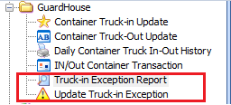

1. **Truck-in Exception:**
2. Select “Loaded”
3. Enter Truck#, Company and Container
4. If Container not found in system, system will add Container as Truck in Exception

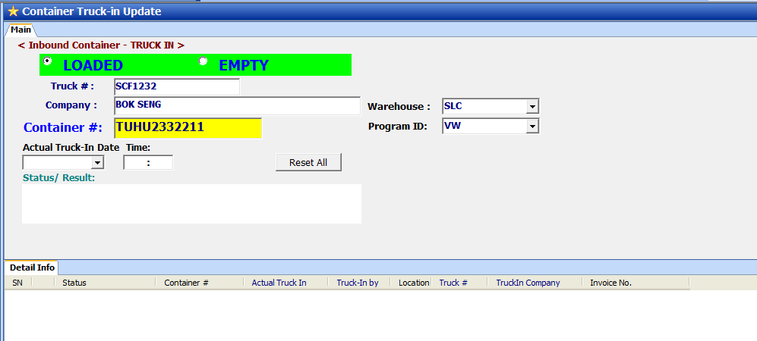

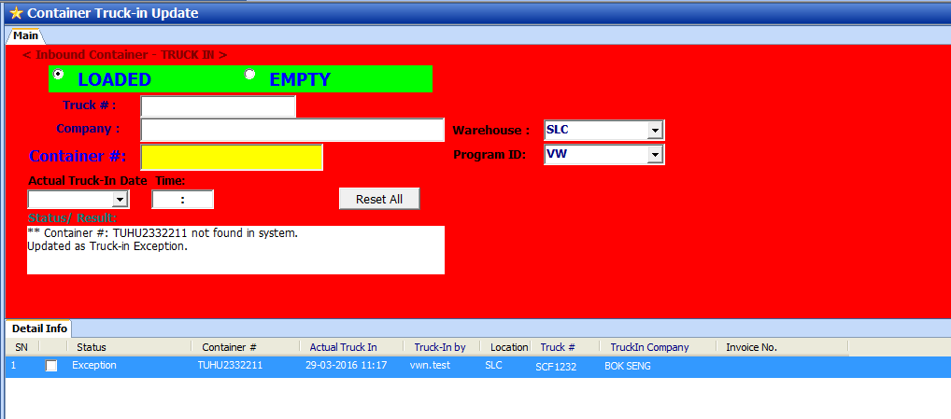

**Message:**

**Container # ….. not found in system.**

**Updated as Truck-in Exception**

**Status = Exception**

**Cancel wrong container truck-in**

In case, the container exception is typo mistake.

User can click button [Cancel Truck-in] to void the current truck-in record.

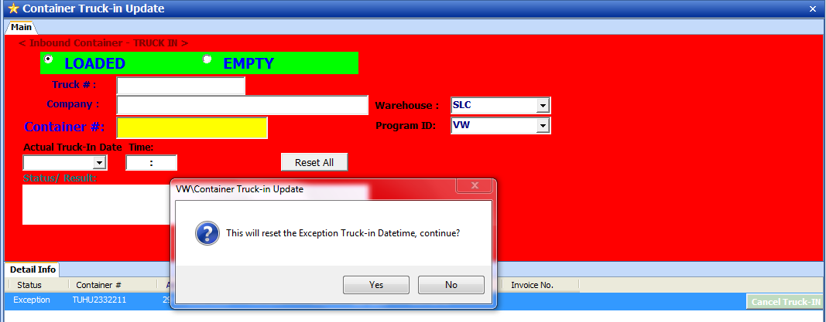

**Click [Cancel Truck-IN]**

* **Click on the icon “ Cancel Truck in” , a message will appear**
* **Then Click on “Yes”**
* **Exception container will be removed from the scan list.**

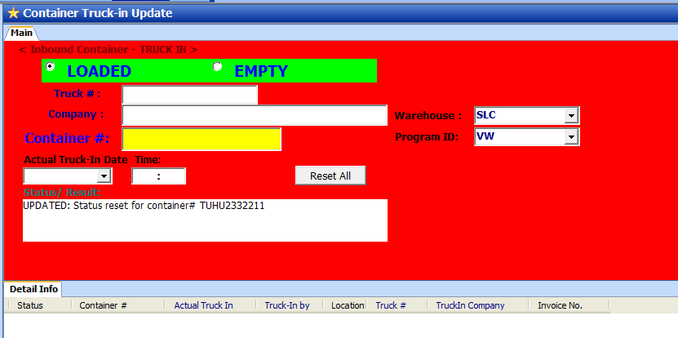

1. **Exception Report**

Retrieve by:

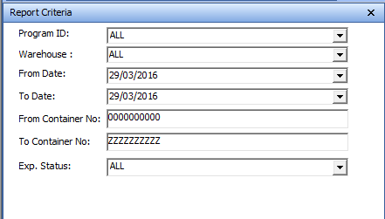

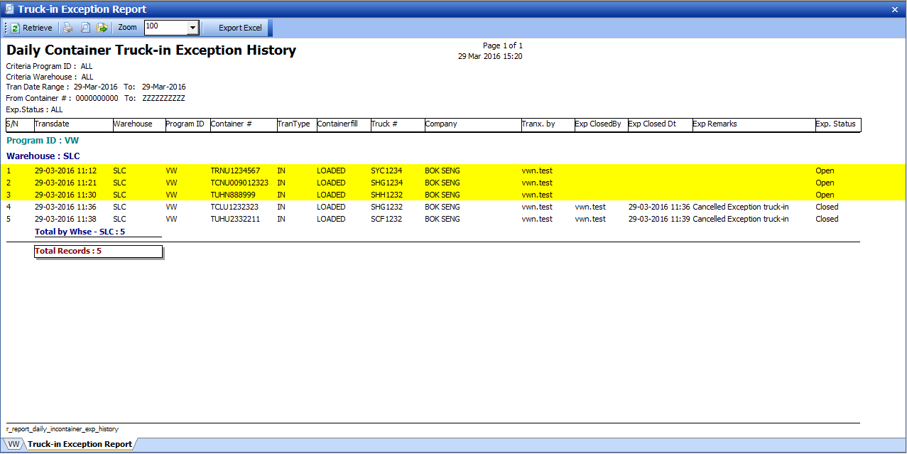

1. **Update Exception truck-in**

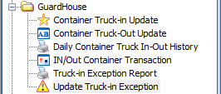

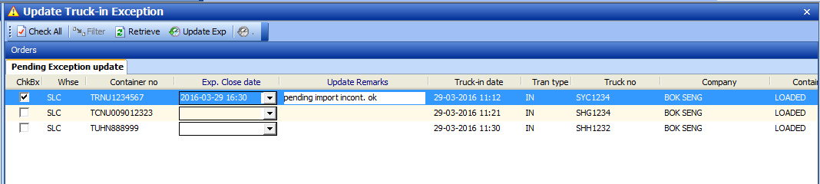

**Steps:**

1. **Select container.**
2. **Update Remarks.**
3. **Click button [Update Exp]** 
4. **A message will prompt up upon successful**

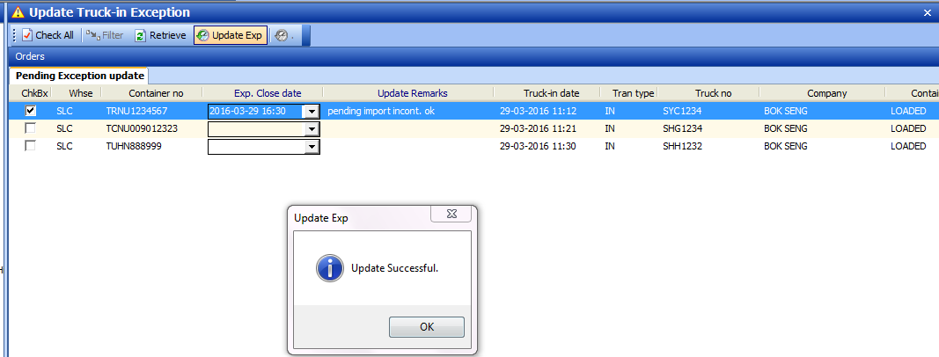

Exception status was closed.

